Panoramix
Integration Specification
 |  | 

Document control
Document revision history
Version | Date | Author | Comments
0.1 | 19/08/2013 | Accenture | Initial version
0.2 | 20/08/2013 | Accenture | Version for review
0.3 | 21/08/2013 | Accenture | Added clarification on certificates and BVAC event
0.4 | 29/08/2013 | Accenture | Update after feedback insurers
0.5 | 04/10/2013 | Accenture | Final update after clarification SFTP issues  - Updated doc with info provided by email  - url’s  - latest version single message  - SFTP no longer needs x.509 for authentication, but a simple SSH (limitation SFTP setup)  - Brought drawing and text in line with wsdl (previous doc contained an old version of the visio)  - Added further clarifications across the document
0.5.1 | 14/10/2013 | Accenture | Added minOccurs="0" to the routingParametersCBFA in the PanoramixTIPSystemServices_protocol-1_0.xsd
0.6 | 21/10/2013 | Accenture | Update with answers to questions received from Assuralia members during integration
0.6.1 | 08/11/2013 | Accenture | Updates following integration with insurers
0.7 | 12/11/2013 | Accenture | Finalised version

Table of Contents
List of Figures 2
List of Tables 3
1 Introduction 4
1.1 Objectives 4
1.2 Intended Audience 4
1.3 Scope 4
1.4 References 4
1.5 Assumptions 4
1.6 Definitions 4
2 Panoramix project – Assuralia BVAC messages 5
3 Message Structure 6
3.1 Single Message 6
3.2 BVAC Event 7
3.3 Example Single message containing a BVAC event 10
4 Integration 11
4.1 Authentication & encryption 11
4.2 Technical Registration 12
4.3 Webservice 14
4.4 SFTP 18
4.5 Retention period 21
4.6 FAQ & Code snippets 22
5 Connection parameters 24
5.1 Webservice 24
5.2 SFTP 24
6 Appendix 25
6.1 Single Message 25
6.2 BVAC Field Definition 25

List of Figures
Figure 1 - Single Message hierarchy overview 6
Figure 2 - Single Message Specification 7
Figure 3 - BVAC Event definition 8
Figure 4 - BVAC Event structure 9
Figure 5 - Example encryption in context of delegation 14
Figure 6 - Get BVAC messages 16
Figure 7 - Error response structure 17
Figure 8 – SFTP XML file structure 20

List of Tables
Table 1 - References 4
Table 2 - Example technical registration parameters 13

Introduction

Objectives
This document establishes a set of requirements and constraints for the interface between insurers and the TIP system for retrieval of BVAC messages.

Intended Audience
This document is intended for use by architects, developers and testers of the applications identified.

Scope
This document outlines the interface requirements to support the Assuralia business events in the TIP system solution. It details the integration procedure expected to be implemented by the insurers be able to use the services offered by the TIP System for retrieval of BVAC messages.

References
Ref | Name | Version | Location
1 | GFD-DPP_Glossary | 0.0.2 | ACN Sharepoint
2 | GFD-DPP_Application_Design_Assuralia | 1.2.0 | ACN Sharepoint
3 | Single message format | 2.0.1 | GFD-DPP SVN
Table 1 - References

Assumptions
No assumptions currently defined.

Definitions
For definitions used in this document, please refer to glossary (see [Ref 1]).

Panoramix project – Assuralia BVAC messages
Next to the national compulsory health insurance (RIZIV-INAMI), a citizen has the possibility to contract complementary coverage for health related out-of-pocket costs with the insurer(s) of his choice.
Contrary to interventions by RIZIV for pharmaceutical products using a third party settlement process, the patient still has to advance the amount and claim reimbursement from his insurer in case of complementary insurance. To this means the pharmacist can issue a BVAC attestation clearly identifying the patient, the product(s) and the price among other things. The patient/insured person submits the BVAC to his insurer by post, handover or other permitted channels to obtain a (partial) reimbursement depending on the specifics of his contract.

As the personal share of medical expenses (portion of the cost not covered by INAMI) is increasing, patients are increasing their complementary coverage. At present an estimated 3 million BVAC attestations are issued yearly.
In the context of the Panoramix project, we will implement an Assuralia flow in the TIP that will automate the transfer of the information contained within the BVAC attestation from pharmacist to insurer enabling reimbursement to the patient/insured person. This will reduce the administrative load for
- the patient: no more manual intervention to claim reimbursement
- the insurer: reduced handling and recoding as structured information is transferred electronically.
This flow can be called by pharmacy software through connector module.
Remark that some use AssurCard as an aggregator to interact with care providers, the TIP will thus transfer the BVAC attestations to AssurCard instead of directly to these respective.
At present only the electronic transfer of the BVAC data from pharmacist to insurer is in scope.

Message Structure

Single Message
The single message format is an XML specification used to communicate pharmaceutical information. The message structure contains a hierarchy of events and entities in its body.
- Events correspond to pharmaceutical care actions performed by the pharmacist.
- Entities are the data objects manipulated by or associated with events.
  - These are either part of, or referenced by, events. The latter is preferred if multiple events reference the same entity.
The following simplified diagram contains fictional elements to illustrate the difference between events and entities. In this case, a revocation is an event that references a dispensation delivery.
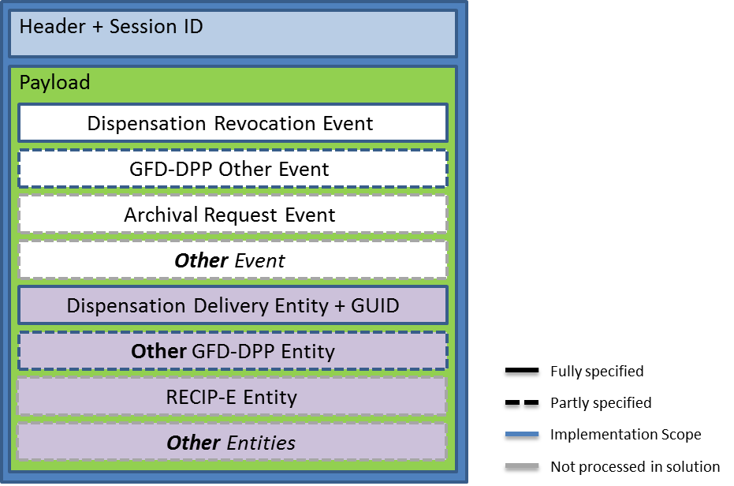
Figure 1 - Single Message hierarchy overview
More specifically, the diagram below shows the structure as it exists within the actual schema.
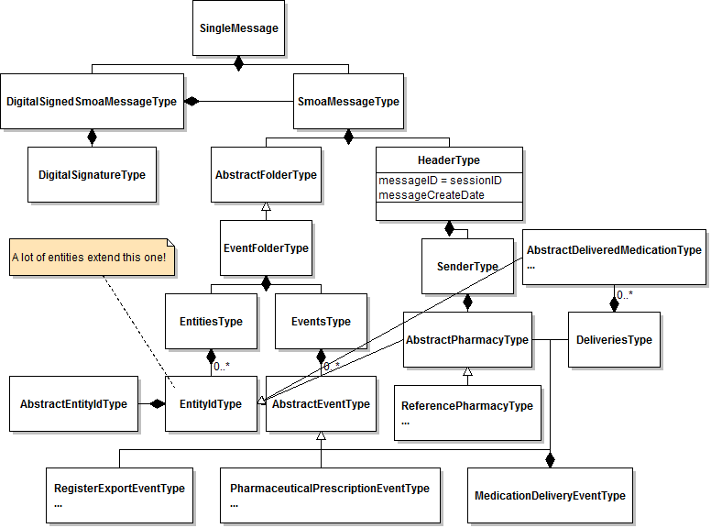
Figure 2 - Single Message Specification
- Black diamond mean “is composed of” (contains)
- White arrow means “extends”
- If no cardinality is written, it means 0..1
- Ellipses (…) in an entity mean the entity has more attributes or extensions not shown in the diagram.

This single message concept will be extended with a new type of event, the “BVAC Event”. The details of the single message can be found in [Ref 3]. Section 6.1 Single Message in the appendix contains the current version of the single message.

BVAC Event
The vehicle for sending Assuralia data is the BVAC document. The BVAC document will be part of the Single Message and will be contained in a new event type “BVAC Event”.
In the diagrams below, the graphical conventions are:
- yellow for a data field;
- white blocks indicate composite elements;
- striped blocks are optional fields not filled in the shown exchanged message.

Message structure of BVAC Event
Figure 3 - BVAC Event definition
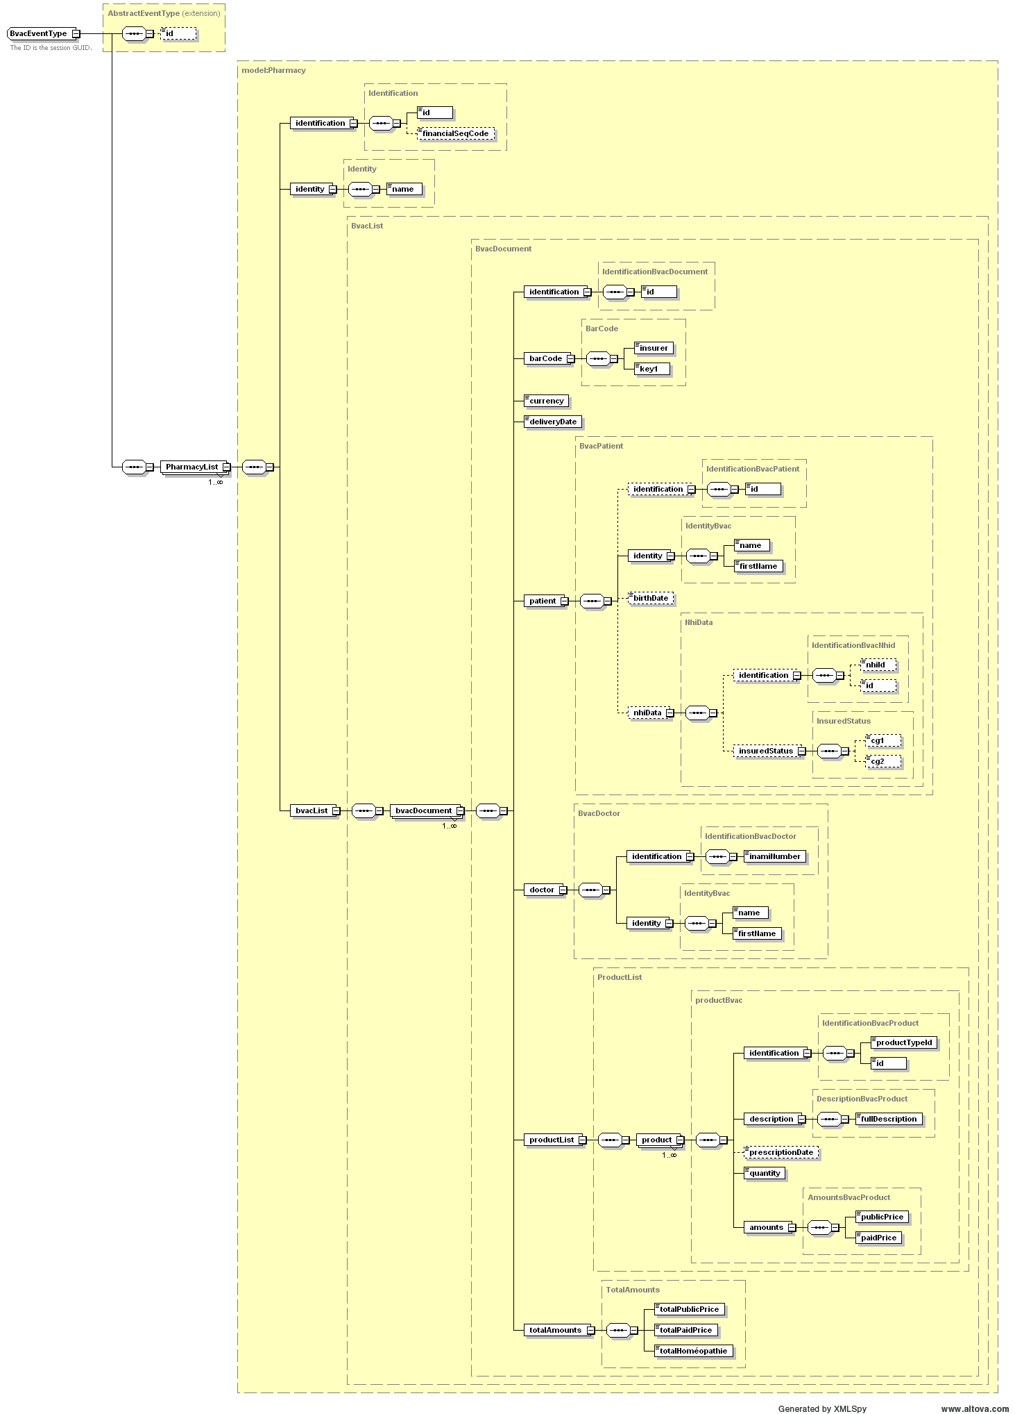
Figure 4 - BVAC Event structure

2 fields of note are the S-GUID and the BVAC Document Id. Both are auto-generated and unique id’s across the pharmacies, TIP System and insurer. The S-GUID is used for end-to-end traceability across any type of message passing the TIP system, where the BVAC document Id is particular to the BVAC message flow. One S-GUID exists per single message and one BVAC document id exists per BVAC message. Since a single message only contains one BVAC document id, there is also a 1 to 1 mapping between both ids, but this cannot be taken as a fixed assumption, since in the future a different setup with more than 1 BVAC message per Single Message could be envisioned.
The insurer is requested to also keep both the S-GUID and BVAC Document ID when treating and archiving the BVAC messages.
Other fields are further defined in section 3.2.2 Field definition.

Field definition
See section 6.2 BVAC Field Definition in the appendix for more details:

Example Single message containing a BVAC event
Following is a sample single message containing a BVAC event.
The return message / flatfile returned by web service / SFTP consists out of a number of these single messages, encrypted and in a encapsulating structure as can be found in sections 4.3 Webservice and 4.4 SFTP

Integration
The “Get BVAC DATA” service will allow to retrieve BVAC messages sent by pharmacies from the TIP system.
The TIP System allows 2 mechanisms:
- SFTP: The TIP Sytem provides file access to the BVAC messages by means of SFTP over SSH.
- Webservice: The TIP System exposes a standard web service that allows access of the BVAC messages for a particular Assuralia member.
Both options imply that some technical processing must be performed on client side (such as encryption/decryption, setting up a SSH connection for SFTP, …). This technical processing must be implemented by the insurers.

Authentication & encryption

Insurer X.509 Certificate for transport (for web service)
The party (insurer or other company) willing to connect to the TIP system using web service is required to request an X.509 certificate from a valid certificate authority with a linked public / private key pair (2048 bits) and needs to provide the public part to the TIP System for configuration. The certificate + public/private key pair is expected to be renewed every 3 years between TIP and Insurer through manual agreement between APB (Farmaflux) and Insurer (or AssurCard). Preferably the certificate is organisational.

This Transport X.509 certificate is used
- Web service
  - The get BVAC data request message is signed with the X.509 certificate of the requestor, which is checked by the TIP System

Insurer SSH key for transport (for SFTP)
The party (insurer or other company) willing to connect to the TIP system using SFTP is required to create a ssh key (RSA 2048 bits) and needs to provide the public part to Farmaflux for configuration.

This SSH key is used
- SFTP
  - Setting up the SSH session with the file server uses the SSH key, combined with the Username Farmaflux will provide

Insurer X.509 Certificate for Encryption (all end-insurers)
Besides the public/private key pair used for transport, we also define a public/private key pair for encryption. Where the transport pair was used to setup a connection with the TIP system, the encryption pair is used to encrypt the messages for the end-insurer. Otherwise said, all insurers willing to receive a BVAC message need to request an X.509 certificate from a valid certificate authority with a linked public /private key pair (2048 bits) and need to provide the public part to Farmaflux for configuration. The certificate + public/private key pair is expected to be renewed every 3 years between TIP system and Insurer through manual agreement between Farmaflux and Insurer (or AssurCard). Preferably the certificate is organisational.

This X.509 certificate is used
- SFTP
  - The content of the file found, is encrypted with the public key of the end-insurer and needs to be decrypted by its private key
- Web service
  - The web service return messages are encrypted with the public key of the end-insurer and need to be decrypted by its private

For an insurer that retrieves its own BVAC messages, the transport and encryption certificates can in fact be the same certificate. It is up to the insurers to decide if they are willing to use the same certificate.

TIP System SSL certificate (for connection through web service)
The insurer willing to use the web service, should have the TIP System SSL certificate installed on its server. This is provided by Farmaflux at time of configuration and is valid for a period of 1 year. Between a period of 3 to 1 month before the end of the year, the insurer will be provided with a new public key.
This SSL certificate is used to setup the HTTPS session when using the webservice approach.

TIP System X.509 certificate (For connection through web service)
The insurer willing to use the web service, should have the TIP System public key on its server. This is provided by Farmaflux at time of configuration and is valid for a period of 3 years. 3 months before the end of the 3 year period, the insurer will be provided with a new public key.

It is used for the get bvac data web service request message which needs to be encrypted with the public key of the TIP System

Technical Registration

Insurer information
In order to allow access to the TIP system to retrieve BVAC messages, the insurer or party retrieving messages for an insurer, needs to provide a number of technical configuration parameters:
- Name
- CBFA number (if insurer)
- End-point-type: SFTP or HTTPS (i.e. web service)
- SSH key or X.509 Certificate used for transport (public part)
- X.509 Certificate used for encryption (public part)
- A delegation list of parties that may retrieve BVAC messages for this insurer
- For SFTP: the IP addresses of the servers going to access the SFTP

Depending on the setup one of both the certificates need to be provided
- An insurer retrieving its own messages needs to provide both certificates
- An insurer which has another party retrieving its messages (delegator) only needs to provide the encryption certificate
- A party retrieving messages for insurers (delegate), only needs to provide the transport certificate

Please note that it can take 2-3 days to activate a new party, so do not delay in requesting the different certificates from your CA of choice.
Please note that for the Acceptance and Production environment other certificates have to be used to maximise security.

Note on switching from SFTP to web service
An insurer is expected to choose or SFTP or Web service. In the case where an insurer wishes to switch from SFTP to Web service, please mind that
- An insurer can only start calling the Get BVAC web service when the insurer configuration is adapted in the TIP System by Farmaflux. As long as Farmaflux does not confirm the configuration change, the insurer will need to keep doing SFTP.
- Once a file has been created for SFTP, it is no longer possible to retrieve the contained BVAC records by web service so when an insurer switches from SFTP to Web Service, it can occur that there are still files present in the SFTP directory of the insurer. In this case it’s up to the insurer to retrieve these files before they are deleted by the nightly deletion batch which deletes files if they are older than a certain number of days (see section 4.5 Retention period)

Delegation of retrieval of BVAC messages
An insurer can delegate the retrieval of its BVAC messages to one or more insurers, or in general other parties having a CBFA number. E.g. Assurcard has a number of Insurers for which it can retrieve BVAC messages.
- Both parties (delegator and delegate) need to have passed the technical registration, and for both parties the respective public keys need to be known (for the delegator this is the encryption key, for the delegate this is the transport key).
- This list of parties to which it delegates, is communicated by the delegator (i.e. the end-insurer) at the time of technical registration.
- Retrieval of the BVAC messages is transparent for a non-delegated party as for a delegated party:
  - Authentication and authorization of the requestor is done on the basis of the transport public/private key-pair of the requestor
  - In the request it is specified for which end-insurer the BVAC messages are meant
  - The distinct BVAC messages are encrypted (message by message) by the encryption public key of the end-insurer
- Important for this setup is also that it is possible (in theory) that multiple parties are allowed to retrieve BVAC messages for one end-insurer. This retrieval happens on a first-come-first-served basis. If one party with access to the messages has retrieved them, then a second party which also has access to these messages will no longer find them on the TIP System.

An example to clarify
Assume we have a party A which retrieves BVAC messages for parties x and y. For completeness sake, we also have insurers S and T retrieving their own messages.
During the technical setup, we will have following information
Name | CBFA | End-point-type | Public Key for transport | Public Key for encryption | Accessible by
A | - | HTTPS | @transport key A@ | - | -
X | 0001 | HTTPS | - | @encryption key x@ | A
Y | 0002 | HTTPS | - | @encryption key y@ | A
S | 0003 | HTTPS | @transport key S@ | @encryption key S@ | S
T | 0004 | SFTP | @transport key T@ | @encryption key T@ | T
Table 2 - Example technical registration parameters

When party A wants to retrieve the BVAC messages for both x and y, he
- Sets up a HTTPS session with the TIP system checking the connection against the SSL certificate of the TIP system
- Sends two requests (i.e. 2 webservice calls), one for CBFA 0001 and one for CBFA 0002. Each request is signed with its private key (@transport key A@)
- Two return messages are returned, each containing a number of BVAC messages, with each BVAC message encrypted with the public keys of the end-insurers (@encryption key x@ & @encryption key y@)

Figure 5 - Example encryption in context of delegation

Webservice

Authentication & secure message transfer
A HTTPS session is setup by the insurer using the TIP systems SSL certificate.
Further authentication is done by signing of request messages with the own private key to allow the TIP System to validate the originator of the message. See section below for further explication where signing is done.

Flow
The BVAC messages are reachable through HTTPS for all authenticated insurers.

- Calling party sets up a HTTPS connection to the TIP System using the TIP system SSL certificate
- Calling party creates and sends a request message, containing
  - An AES-256 symmetric key, encrypted with the public key of the TIP system (Algorithm: RSA/ECB/PKCS1Padding)
  - Request parameters encrypted with said symmetric key, and containing
    - CBFA number for which the BVAC messages need to be retrieved
    - REQUESTOR_ID of the party doing the transport (i.e. the CBFA number of simply “ASSURCARD” for Assurcard)
    - Date-time in format yyyy-MM-ddTHH:mm:ss.fffzzz
    - Signature: concatenation of the CBFA number “;” and the date-time (in format ddMMyyyyHHmmss. (E.g. 17102013110341)), signed with the private key of the calling party (e.g. 5000;17102013110341 )
- TIP System checks the request message
  - Decrypts the symmetric key with the private key of the TIP system (Algorithm: RSA/ECB/PKCS1Padding)
  - Decrypts the request parameters with said symmetric AES key
  - Checks the signature against the transport public key of the calling party
  - Checks if the calling party has access to the BVAC messages of the CBFA indicated in the request message (using the parameters provided during technical registration)
- TIP System creates a return message
  - Retrieves the BVAC messages for the CBFA indicated. These are each in its turn already encrypted with the encryption public key of the insurer to which the CBFA number belongs
  - Puts these BVAC messages (single message format) together in an aggregated BVAC List
  - Encrypts the BVAC list with a generated AES-256 symmetric key
  - Encrypts the symmetric key with the transport public key of the calling party and adds it to the BVAC
  - Returns the BVAC list
- Calling party treats the return message
  - Depending on the setup
    - In the case where the decryption private key of the delegator is kept at the delegate: Decrypts the individual BVAC messages with the decryption private key linked to the insurer for which the messages were requested
    - In the case where the decryption private key of the delegator is not kept at the delegate: Passes along the BVAC messages to the delegator for which it retrieved the message. This delegator party is then responsible for decrypting the individual BVAC messages with its decryption private key.

Input & Output Message
Figure 6 - Get BVAC messages

Some important notes:
- As stated before, the grey box means that this content is in encrypted format. This means that the request parameters, the symmetric key and the single message only appear in encrypted (sealed) format.
- In the input message, the structure ‘routing parameters’ is optional (see the dashed box). It is foreseen for future extension sake. This means that you do not have to provide this structure. However, if you do provide it, it should contain the CBE number to which the TIP system public key belongs (i.e. 0406753266 at the writing of this document).
- In the output message, the field TIP ID in the routing info is optional (see the dashed box). It is foreseen for future extension sake. Currently it will not be returned.
- The output message contains a BVAC list, which contains a number of BVAC structures. Each BVAC structure, contains one single message structure (see 3.1 Single Message), which in its turn contains one BVAC event (see 3.2 BVAC Event), which contains one BVAC document.
- The output message always contains a success or error message, together with the error text in Dutch, French and English. See section 4.3.6 Messages for an overview of the success and error message at the time of writing of this document.
Figure 7 - Error response structure

Sample input and output message
The input message contains request parameter, which are sealed with a symmetric key, after which the symmetric key is also sealed on its turn by the public key of the TIP System. Please find below
- A sample xml of the request parameters before sealing with the symmetric key
- A sample xml of the total input message, after sealing the request parameters. We also included the optional routing parameters (see before).
- A sample xml of the output message

WSDL and XSD
Below the current format of WSDL and corresponding XSD’s for the get bvac data web service. There are two xsd’s, one that corresponds to the webservice, and one that corresponds to the encrypted part of the request parameters.

Messages
Below are the messages which can be received in the output of the get bvac data call.
Message code | Message type | Message (EN) | Message (FR) | Message (NL)
TIP_200 | FUNCTIONAL | Success | Succès | Succes
TIP_999 | TECHNICAL | Technical error on TIP System | Erreur technique TIP System | Technische fout op TIP systeem.
TIP_ERROR_ASSURALIA_DECRYPTION_FAILED | TECHNICAL | The Assuralia decryption failed. | La decryption de Assuralia a échouer. | Assuralia decryptie is gefaald.
TIP_ERROR_BVAC_CONFIGURATION_TRANSPORT | FUNCTIONAL | The specified transport method is not supported {0} | La method de transport spécifié n est pas supportée: {0} | De gespecifierde transport methode is niet gesupporteerd {0}
TIP_ERROR_BVAC_CONFIGURATION_REQUESTORID | FUNCTIONAL | The bvac configuration for the given requestor id can not be retrieved {0} | La bvac configuration ne peut être récupérée pour le requestorId : {0} | De bvac configuration voor de opgegeven requestor id kan niet worden opgehaald: {0}
TIP_ERROR_BVAC_CONFIGURATION_CBFA | FUNCTIONAL | The bvac configuration for the given cbfa id can not be retrieved {0} | La bvac configuration ne peut être récupérée pour le cbfa : {0} | De bvac configuration voor de opgegeven CBFA kan niet worden opgehaald: {0}
TIP_ERROR_ASSURALIA_REQUESTOR_NOT_AUTHORIZED | FUNCTIONAL | The requestor is not authorized to get the bvac messages | Le requestor n'est pas authorisé à consulter ces bvac messages | De requestor is niet geauthorizeerd om de cbfa data op te vragen
TIP_ERROR_ASSURALIA_COULD_NOT_VERIFY_SIGNATURE | TECHNICAL | Could not verify the signature. | Pas possible de verifier la signature. | Kon de signature niet verifiëren.
TIP_ERROR_ASSURALIA_REQUESTOR_SIGNATURE_NOT_VERIFIED | FUNCTIONAL | The requestor signature is not verified. | La signature de requstor n'est pas verfié. | De requestor signature is niet geverifiërd.
TIP_ERROR_ASSURALIA_NO_TRANSPORT_KEY | FUNCTIONAL | There is no transport key found. | Aucune transport key trouvée. | Er is geen transport key gevonden.
TIP_ERROR_ASSURALIA_NO_ENCRYPTION_KEY | FUNCTIONAL | There is no encryption key found. | Aucune encryption key trouvée. | Er is geen encryption key gevonden.
TIP_ERROR_GENERATING_AES_KEY | TECHNICAL | Failed to generate the AES key. | Pas posible de génerer un AES key | Error bij het genereren van een AES key.

SFTP

Authentication & secure message transfer
The access to the SFTP directories are configured on infrastructure to be only accessible by the authenticated insurer by verifying their public key. The TIP SFTP setup will associate the Username of the insurer with the SSH Key. The data is transferred from TIP to Insurer through a secure channel (SSH-2) with data encryption based on a temporary agreed symmetric session key based on AES algorithm.

Flow
- The TIP system will have a 4-daily “BVAC extract” batch that will extract all BVAC messages for every insurer that is configured with end-point-type = SFTP. The distinct BVAC messages are encrypted with the encryption public key of the target insurer and grouped into an aggregate file per CBFA
- The retrieving party sets up an SFTP connection to the TIP System file server using its SSH key and the Username provided by Farmaflux
- The TIP System file server only allows access to the directories belonging to the insurers for which the retrieving party has access (using the parameters provided during technical registration)
- The file can then be picked up by the retrieving party through SFTP connection
- After successful retrieval of the file, the retrieving party is expected to delete the file. This indicates to the TIP System that the retrieval was a success.
- Depending on the setup, the calling party
  - In the case where the decryption private key of the delegator is kept at the delegate:
    - Decrypts the symmetric key (AES-256) with the decryption private key linked to the insurer for which the messages were requested
    - Decrypts the individual BVAC messages using the provided the symmetric key
  - In the case where the decryption private key of the delegator is not kept at the delegate:
    - Passes along the BVAC messages to the delegator for which it retrieved the message. This delegator party is then responsible for decryption

Please mind that since we do not know which party will be retrieving the file, we cannot encrypt the aggregate message. Only the individual messages out of which the aggregate message is made up, are encrypted.

Output File
There is one output directory for each CBFA
The file name of the nightly extracts, is BVAC-<CBFA>-<datetime>.xml where <CBFA> is the CBFA number of the insurer and <date> is the datetime of the extract.
E.g. for the party x as in our previous example, you could have following files (assuming the files where not retrieved in the past 2 days).
/3333/BVAC-3333-20130819 233252.xml
/3333/BVAC-3333-20130820 233012.xml
The file format is XML and has following structure:
Figure 8 – SFTP XML file structure
An example file would be:
<BvacList>
<Bvac>
<CBFA>5000</CBFA>
<SGUID>sguid_1</SGUID>
<BvacDocumentId>document_1</BvacDocumentId>
<EncryptedSymmetricKey>VGhpcyBpcyBhbiBlbmNyeXB0aW9uIGtleQ==</EncryptedSymmetricKey>
<SingleMessageSealed>VGhpcyBpcyBhbiBub3QgZW5jb2RlZCBidmFjIG1lc3NhZ2U=</SingleMessageSealed>
</Bvac>
<Bvac>
<CBFA>5000</CBFA>
<SGUID>sguid_1</SGUID>
<BvacDocumentId>document_1</BvacDocumentId>
<EncryptedSymmetricKey>VGhpcyBpcyBhbiBlbmNyeXB0aW9uIGtleQ==</EncryptedSymmetricKey>
<SingleMessageSealed>VGhpcyBpcyBhbiBub3QgZW5jb2RlZCBidmFjIG1lc3NhZ2U=</SingleMessageSealed>
</Bvac>
</BvacList>

Please mind that
- This structure is exactly the same as the inner structure returned via the web service (also see the xsd’s provided in the chapter on webservice)
- This file contains multiple ‘Single Messages’, namely one per BVAC document.
- The S-GUID and Document ID are present in the file for easy reference

Retention period
The messages are kept on the queue / on the file server for a configurable period which is currently set at 14 calendar days. If a message is still on the queue or on the file server after 14 calendar days have passed, they will be deleted by a deletion batch at night.

FAQ & Code snippets

General
- When creating the signature it’s important to have the correct date structure.
  - Date-time in format yyyy-MM-ddTHH:mm:ss.fffzzz (e.g. 2013-11-08T12:14:47.495+01:00)
  - Signature: concatenation of the CBFA number “;” and the date-time (in format ddMMyyyyHHmmss. (E.g. 17102013110341)), signed with the private key of the calling party (e.g. 5000;17102013110341

.net
- For the RSA encryption/decryption it’s important to force PKCS# padding. Snippet below:
RSACryptoServiceProvider rsaPublicKeyEncryptor = ((RSACryptoServiceProvider)publicKeyCert.PublicKey.Key
byte[] encryptMessage = rsaPublicKeyEncryptor.Encrypt(Encoding.UTF8.GetBytes("Hello world"), false);

- What is the size of IV for the AES encryption?
  - 16 Bytes (256bits)
- Because the IV vector is needed some extra steps are needed for the encryption
  - The first 16Bytes of the sealed message are reserved for the IV.
- How to initialize the vector?
byte[] ivArr = { 1, 2, 3, 4, 5, 6, 6, 5, 4, 3, 2, 1, 7, 7, 7, 7 };
byte[] IVBytes16Value = new byte[16];
Array.Copy(ivArr, IVBytes16Value, 16);
var keyBytes = new byte[32];
var secretKeyBytes = Encoding.UTF8.GetBytes(secretKey);
Array.Copy(secretKeyBytes, keyBytes, Math.Min(keyBytes.Length, secretKeyBytes.Length));
return new RijndaelManaged {
Mode = CipherMode.CBC,
Padding = PaddingMode.PKCS7,
KeySize = 256,
BlockSize = 128, //256,
Key = keyBytes,
IV = IVBytes16Value
};

Java
- What is the algorithm used to verify the signature?
  - Signature signature = Signature.getInstance("SHA1withRSA");
- How to AES encrypt?
public byte[] encryptAes(byte[] dataToEncrypt, SecretKeySpec aesKey) {
byte[] encryptedData = null;byte iv[] = new byte[16];
SecureRandom random = new SecureRandom();
random.nextBytes(iv);
IvParameterSpec ivspec = new IvParameterSpec(iv);
Cipher aesCipher = Cipher.getInstance("AES/CBC/PKCS5Padding");
aesCipher.init(Cipher.ENCRYPT_MODE, aesKey, ivspec);
encryptedData = aesCipher.doFinal(dataToEncrypt);
byte[] combined = new byte[iv.length + encryptedData.length];
System.arraycopy(iv, 0, combined, 0, iv.length);
System.arraycopy(encryptedData, 0, combined, iv.length, encryptedData.length);
return Base64.encodeBase64(combined);
}
- How to AES decrypt?
public byte[] decryptAes(byte[] encryptedData, byte[] key) {
byte[] decryptedData = null;
byte[] iv = new byte[16];
System.arraycopy(encryptedData, 0, iv, 0, iv.length);
SecretKeySpec secretKeySpecy = new SecretKeySpec(key, "AES");
Cipher aescipher = Cipher.getInstance("AES/CBC/PKCS5Padding");
aescipher.init(Cipher.DECRYPT_MODE, secretKeySpecy, new IvParameterSpec(iv));
byte[] encryptedDataWithOffset = new byte[encryptedData.length - 16];
System.arraycopy(encryptedData, 16, encryptedDataWithOffset, 0, encryptedDataWithOffset.length);
decryptedData = aescipher.doFinal(encryptedDataWithOffset);
String SealedMessageDecrypted = new String(decryptedData, "UTF-8");
return decryptedData;
}
- How to do RSA encryption?
private byte[] encryptRsa(PublicKey publicKey, byte[] clearData) {
Cipher rsa = Cipher.getInstance(ENCRYPTION_ALGORITHM);
rsa.init(Cipher.ENCRYPT_MODE, publicKey);
ByteArrayOutputStream byteOutputStream = new ByteArrayOutputStream();
CipherOutputStream os = new CipherOutputStream(byteOutputStream, rsa);
os.write(clearData);
os.flush();
os.close();
return Base64.encodeBase64(byteOutputStream.toByteArray());
}
- How to do RSA decryption
private byte[] decryptRsa(PrivateKey privateKey, byte[] data) {
Cipher rsa = Cipher.getInstance(ENCRYPTION_ALGORITHM);
rsa.init(Cipher.DECRYPT_MODE, privateKey);
ByteArrayOutputStream byteOutputStream = new ByteArrayOutputStream();
CipherOutputStream os = new CipherOutputStream(byteOutputStream, rsa);
os.write(data);
os.flush();
os.close();
return byteOutputStream.toByteArray();
}

Connection parameters

Webservice
The acceptance webservice can be found on the url
https://acc-tip.gfd-dpp.be/be-apb-gfddpp-services-TIPSystem/PanoramixTIPSystemServices?wsdl

SFTP
The IP addresses to connect to the SFTP for each environment

Acceptance
- IP Addresses: 81.247.254.229
- Port: 22

Production
- IP Addresses: 81.247.254.84
- Port: 22

Appendix

Single Message

BVAC Field Definition

– End of document –

